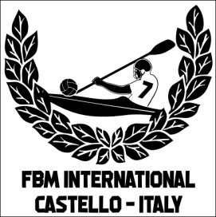 | ‘SUMMER CAMP’  REGISTRATION FORM  Castello di Porpetto (UD) Italy  8 - 11 July 2025  ORGANISED BY NATISONE KAYAK CLUB Manzano & KAYAK FIUME CORNO Castello

TEAM INFORMATION
TEAM NAME:
Nome SQUADRA:
TOTAL NUMBER OF PERSONS IN GROUP
Totale NUMERO di persone nel gruppo
PERSON RESPONSABLE:
Persona RESPONSABILE:
CONTACT PHONE NUMBER:
Numero CONTATTO:
E-MAIL:
indirizzo e-mail:
ARRIVAL DATE & HOUR
Data e ora di arrivo
DEPARTURE DAY & HOUR
Data e ora di partenza
Return this form within 30th June 2025 to fbm.challengetrophy@gmail.com to notify us of your team’s participation in this year’s ‘Summer Camp 2025’
Thank you.

